

Merkel is No Angel But a Hitler
October 21, 2012
For a time we’ve been searching for confirmation on the link between Germany’s Nazi past on the present German government.
Lo, and behold…

Young Angela Merkel with Adolf Hitler
This does not only confirm that, indeed, the incumbent Chancellor of Germany Angela Merkel is a Nazi but more astoundingly, Adolf Hitler did survive World War Two as this picture suggests this was taken post war.
So, the next time you meet Angela, just greet her, “Heil, Hitler” with that snappy fully extended right-handed salute. It should remind her who she really is.

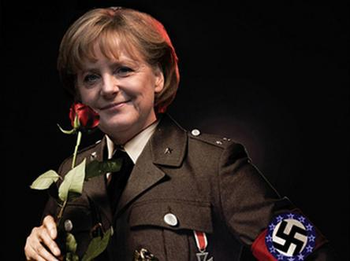

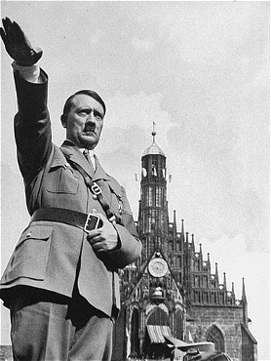

‘Out of Greece!’: Special forces march in uniform, chant in anti-Merkel protest
http://www.youtube.com/watch?v=FLU3vhRfR1Y
Scores of commandos, sailors and paratroopers in their uniforms gathered in Athens on the day of the German Chancellor’s visit – but not to help with keeping the peace. Instead, they staged a march, chanting “Merkel, out of Greece!”
Marching in formation, they also chanted “Together, together, Nazis get out!”
The crowd in the street supported the reservists with rousing cheers. Many of the viewers joined the protesters in their disciplined march.
http://eclinik.wordpress.com/2012/10/21/merkel-is-no-angel-but-a-hitler/

