The Real Truth: Rodney King’s Beating & the L.A. Riots
Wednesday, January 29, 2014 15:13

Rodney King, Violence, PCP, L.A. Riots, Illuminati, Black, White, Race War
The Illuminati used the Rodney King beating to further their agenda of creating an enviorment of extreme racial tension. Rodney King was a pawn to discredit the Blacks in America. In the end the manufactured hate led to the destroying of their very own homes, property & businesses in South Central Los Angeles all by design.
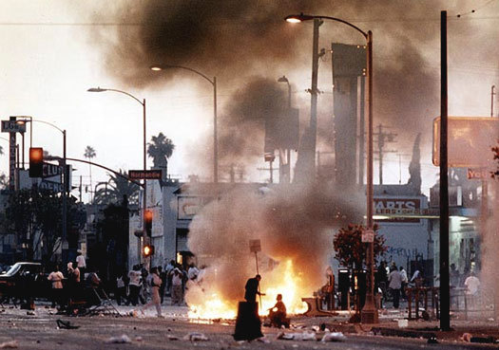
July 27, 1987: According to a complaint filed by his wife, King beat her while she was sleeping, then dragged her outside the house and beat her again. King was charged with battery and pleaded “no contest.” He was placed on probation and ordered to obtain counseling. He never got the counseling.
November 3, 1989: King, brandishing a tire iron, ordered a convenience store clerk to empty the cash register. The clerk grabbed the tire iron, causing King to fall backwards and knock over a pie rack. King swung the rack at the clerk and fled the store with $200. King was arrested and charged with assault with a deadly weapon, second-degree robbery, and intent to commit great bodily injury. In a plea agreement, King pleaded guilty to the robbery charge and the other charges were dropped. He was sentenced to two years in prison, but was paroled on December 27, 1990.
The Arrest of Rodney King on March 3, 1991
March 3, 1991: After being seen speeding on the 210 freeway by CHP officers, King led them on a chase at speeds estimated at up to 110 to 115 mph. When finally stopped, King refused requests to get into the prone position and appeared to charge one of the officers. He was beaten and arrested. King was charged with felony evading. Charges were later dropped.
King’s 3/3/91 Arrest Record
King’s Trouble with the Law After March 3, 1991
May 11, 1991: King was pulled over for having an excessively tinted windshield. Although King was driving without a license and his car registration had expired, King was not charged.
May 28, 1991: King picked up a transvestite prostitute in Hollywood who happened to be under surveillance by LAPD officers. King and the prostitute were observed in an alley engaging in sexual activity. When the prostitute spotted the officers, King sped away, nearly hitting one of them. King later explained that he thought the vice officers were robbers trying to kill him. No charges were filed.
June 26, 1992: King’s second wife reported to police that King had hit her and she feared for her life. King was handcuffed and taken to a police station, but his wife then decided against pressing charges.
July 16, 1992: King was arrested at 1:40 A.M. for driving while intoxicated. No charges were filed.
August 21, 1993: King crashed into a wall near a downtown Los Angeles nightclub. He had a blood alcohol level of 0.19. King was charged with violating his parole and sent for sixty day to an alcohol treatment center. He was also convicted on the DUI charge and ordered to perform twenty days of community service.
May 21, 1995: King was arrested for DUI while on a trip to Pennsylvania. King failed field sobriety tests, but refused to submit to a blood test. He was tried and acquitted.
July 14, 1995: King got into an argument with his wife while he was driving, pulled off the freeway and ordered her out of the car. When she started to get out, King sped off, leaving her on the highway with a bruised arm. King was charged with assault with a deadly weapon (his car), reckless driving, spousal abuse, and hit-and-run. King was tried on all four charges, but found guilty only of hit-and-run driving.
March 3, 1999: King allegedly injured the sixteen-year-old girl that he had fathered out of wedlock when he was seventeen, as well as the girl’s mother. King was arrested for injuring the woman, the girl, and for vandalizing property. King claimed that the incident was simply “a family misunderstanding.”
September 29, 2001: King was arrested for indecent exposure and use of the hallucinogenic drug PCP.
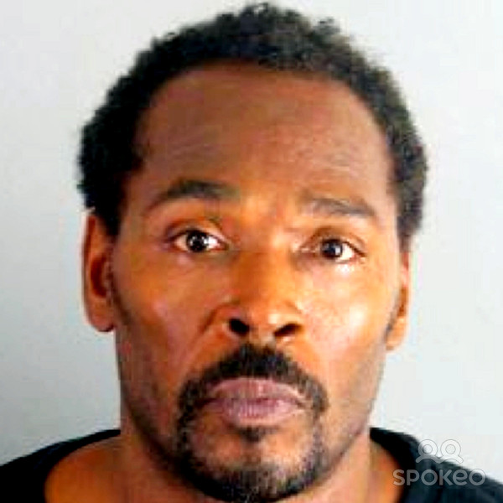
http://law2.umkc.edu/faculty/projects/ftrials/lapd/kingarrests.html
http://beforeitsnews.com/conspiracy-theories/2014/01/the-real-truth-rodney-kings-beating-the-l-a-riots-2459070.html

